**ASSIGNMENT - 1**

**MODULE 6**

**S3 – BUCKET CREATION**

**DONE BY   
RANJITH KUMAR**

**Tasks To Be Performed:**

1. Create an S3 Bucket for file storage.

2. Upload 5 objects with different file extensions.

STEP 1 : Open S3 from aws services\

STEP 2 : Select buckets > Create bucket

STEP 3 : Bucket name should be globally unique name

STEP 4 : Select object ownership , public access, bucket versioning , encryption , object lock required to create a bucket

STEP 5 : Bucket has been created.

STEP 6 : Now select our bucket to upload files in it

STEP 7 : Select upload and then click add files

STEP 8 : Select five objects with different file extensions (jpg,txt,pdf,ppt,zip)

STEP 9 : Uploaded objects to the bucket

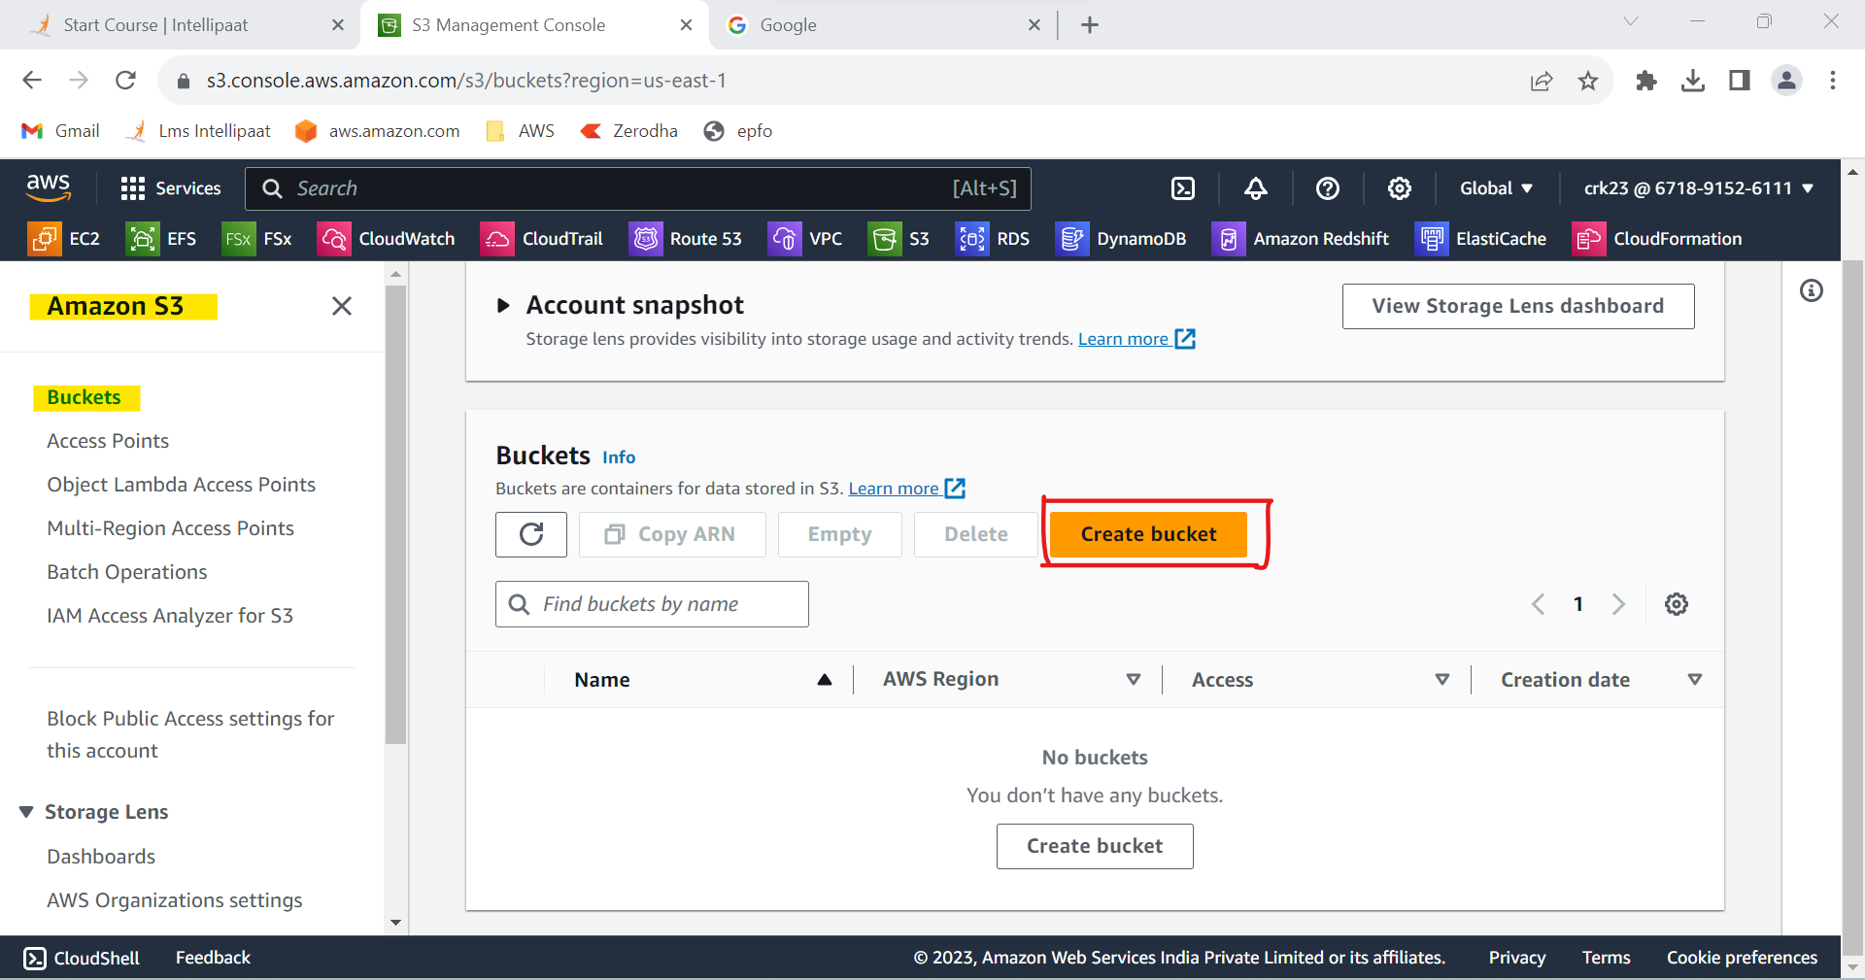

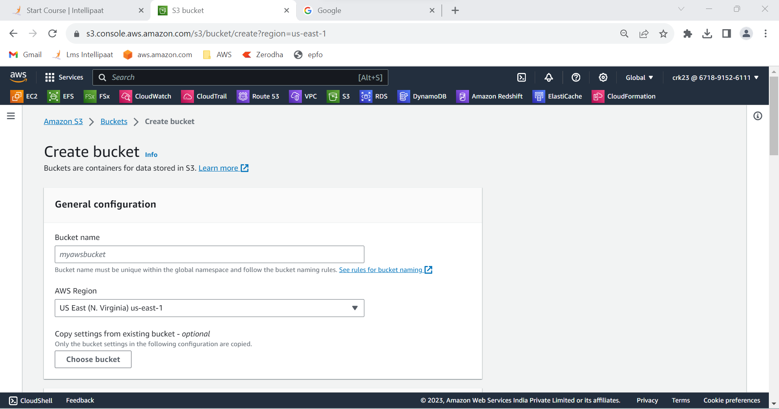

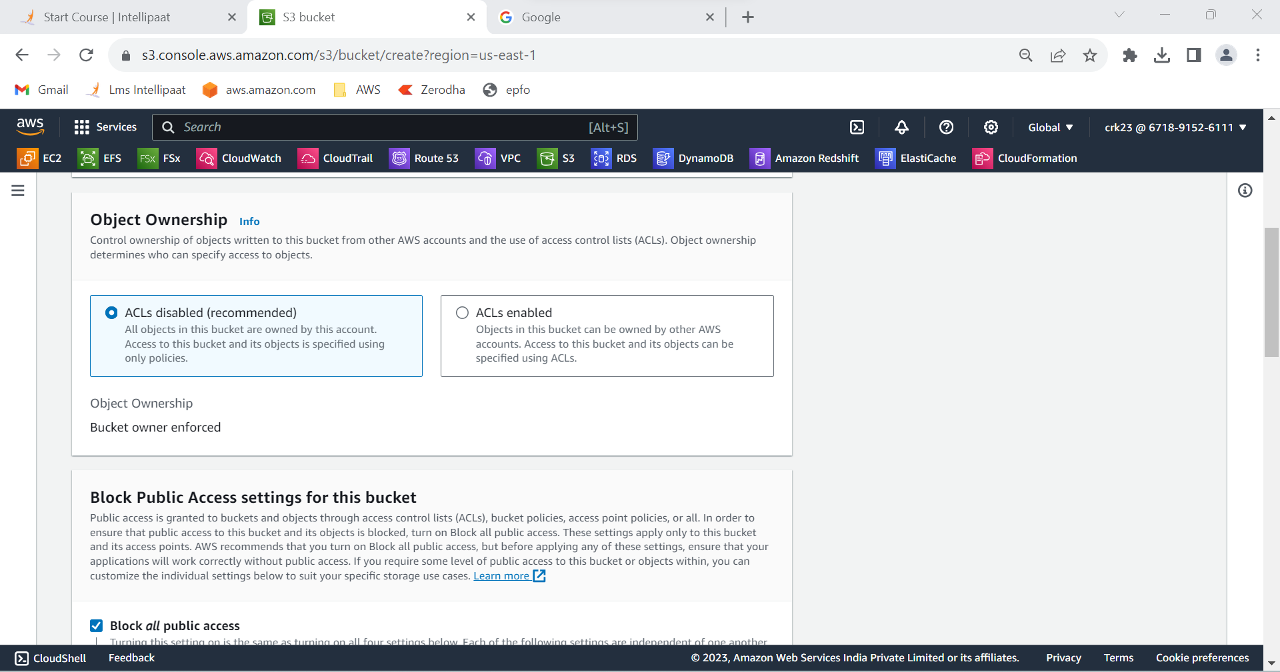

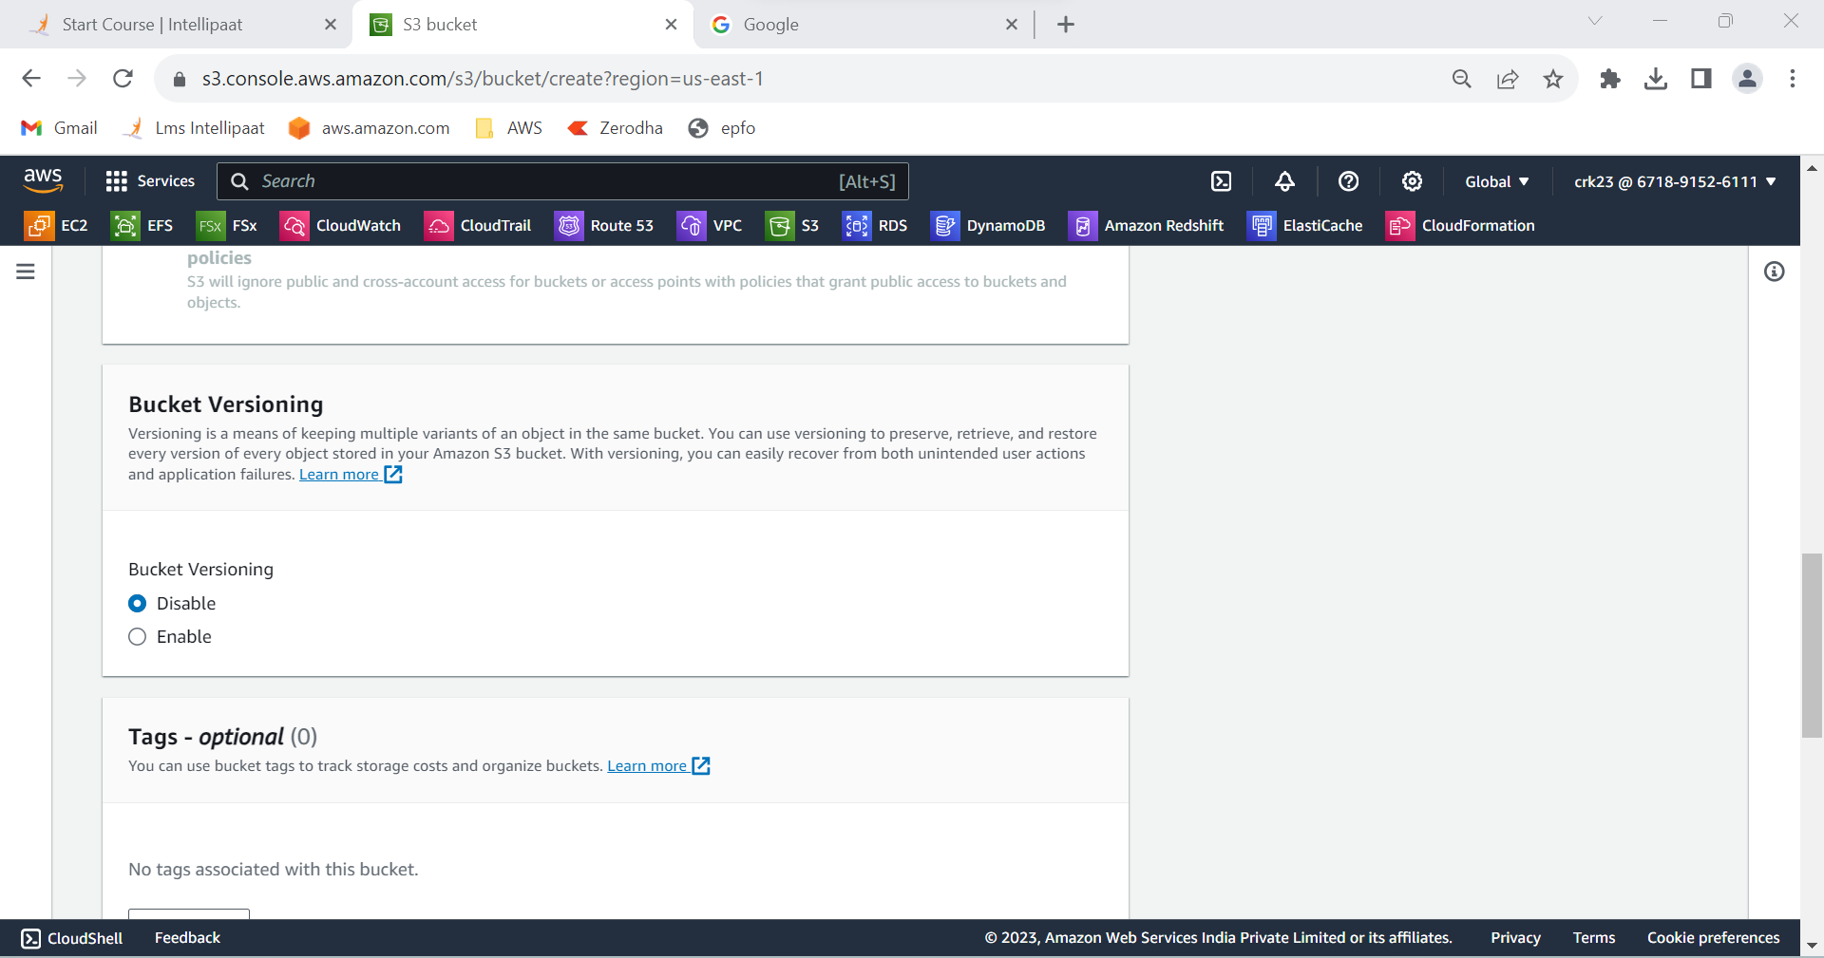

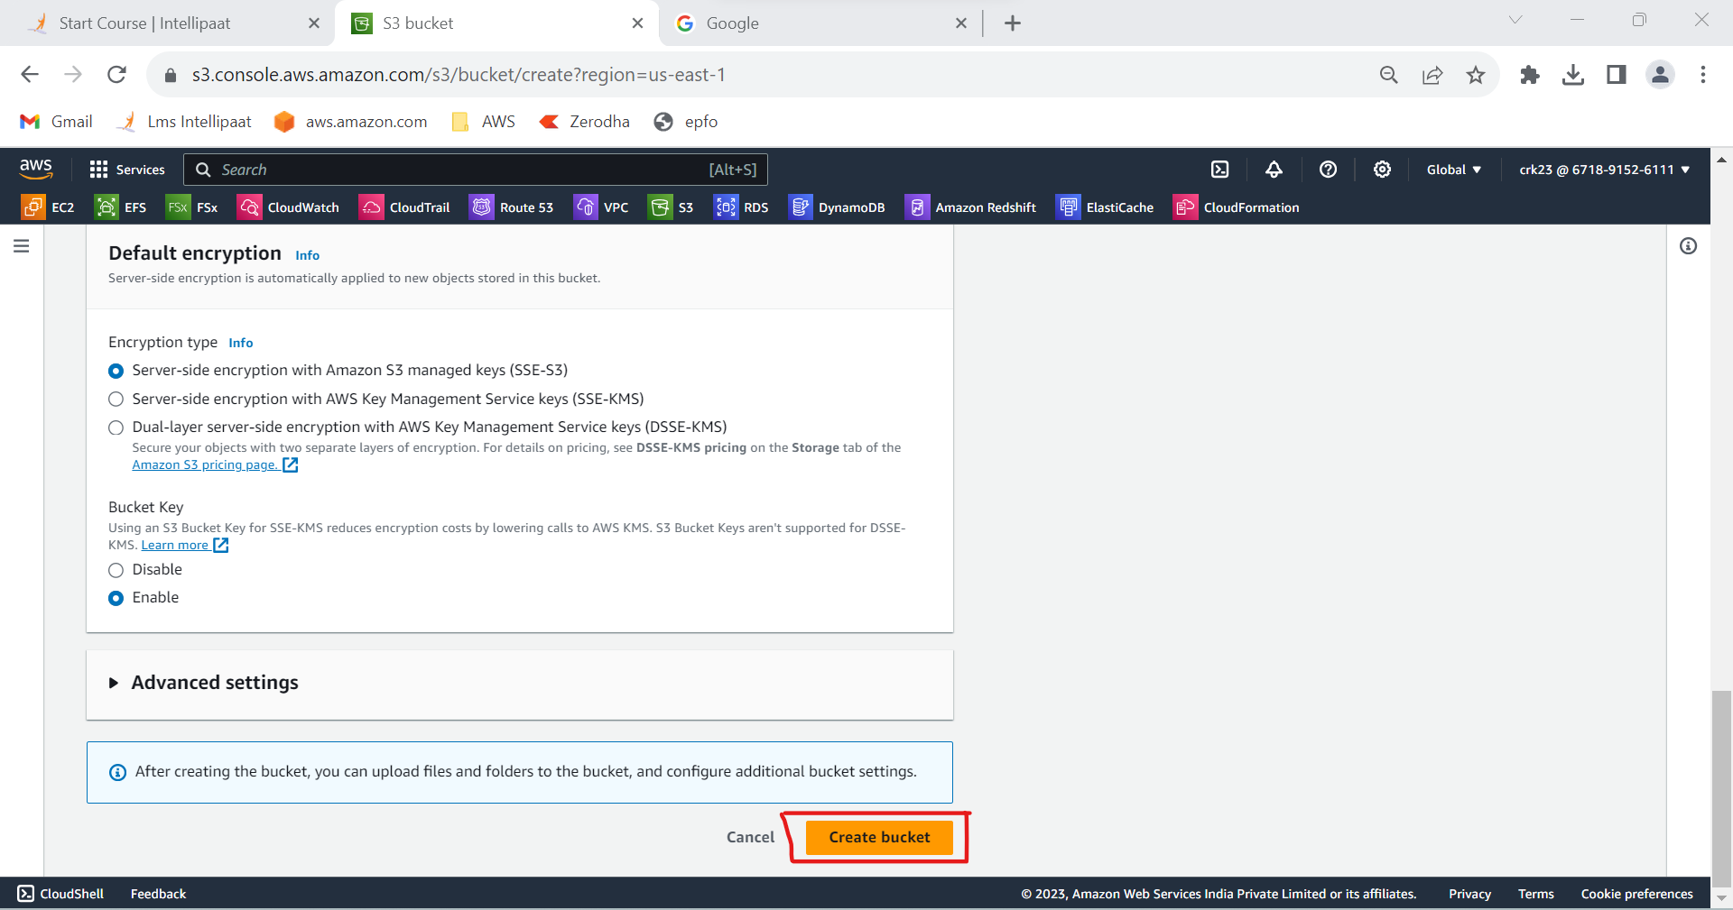

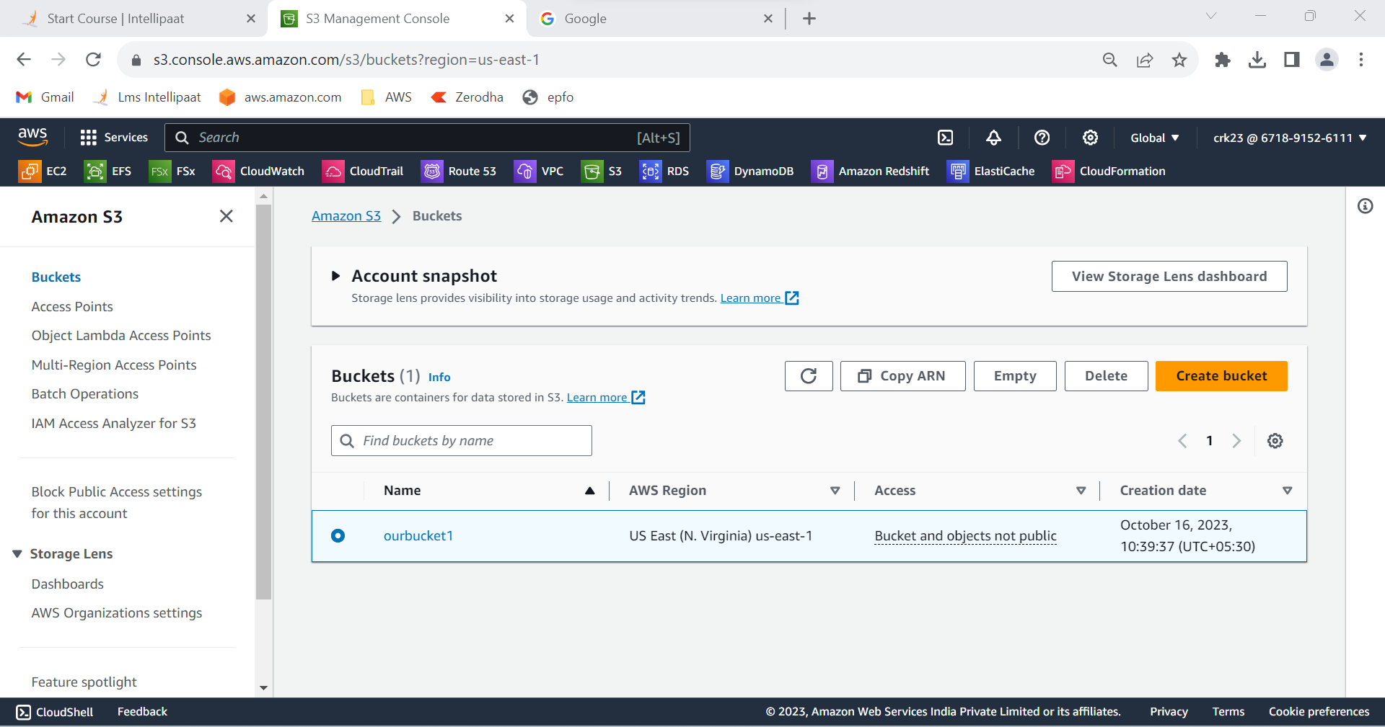

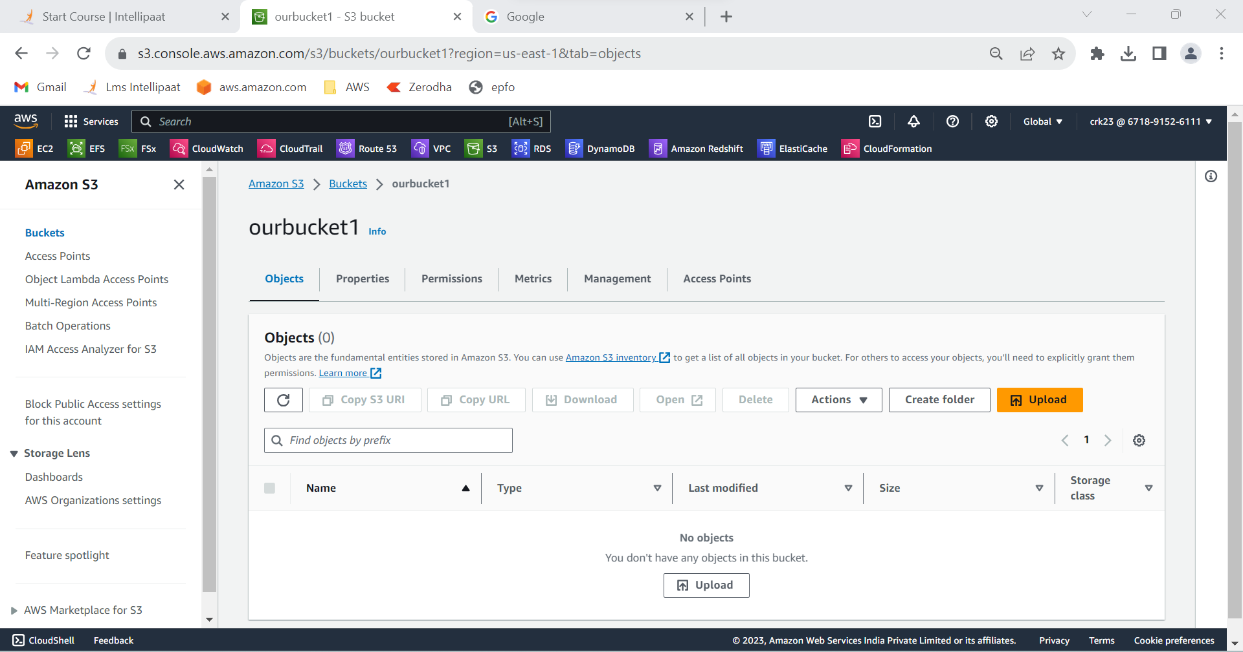

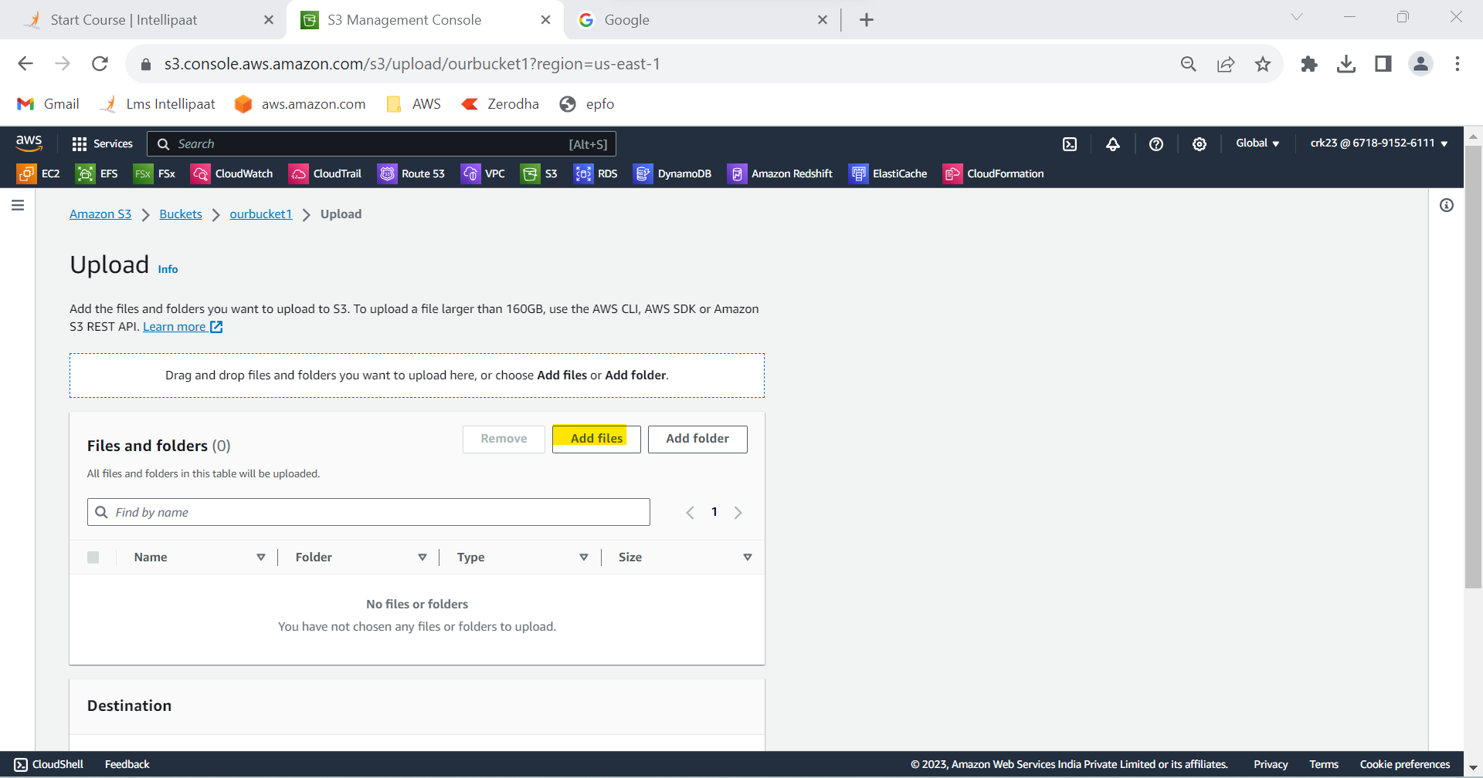

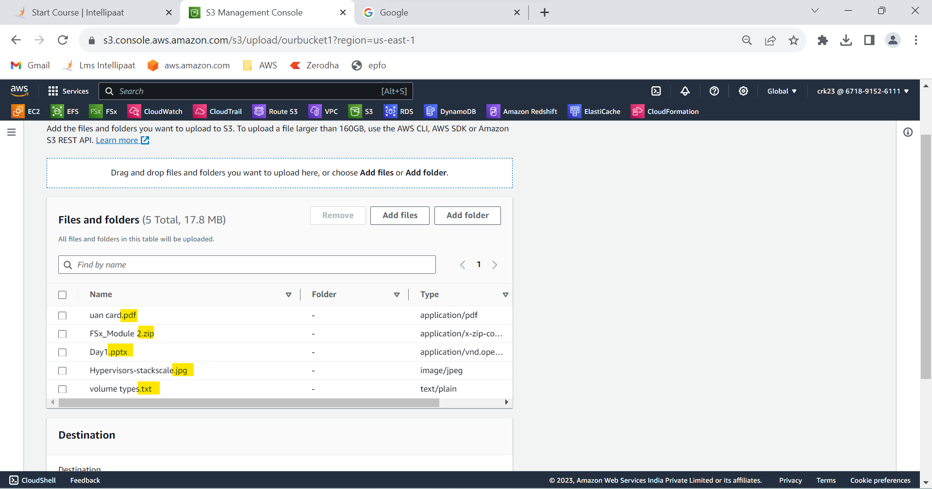

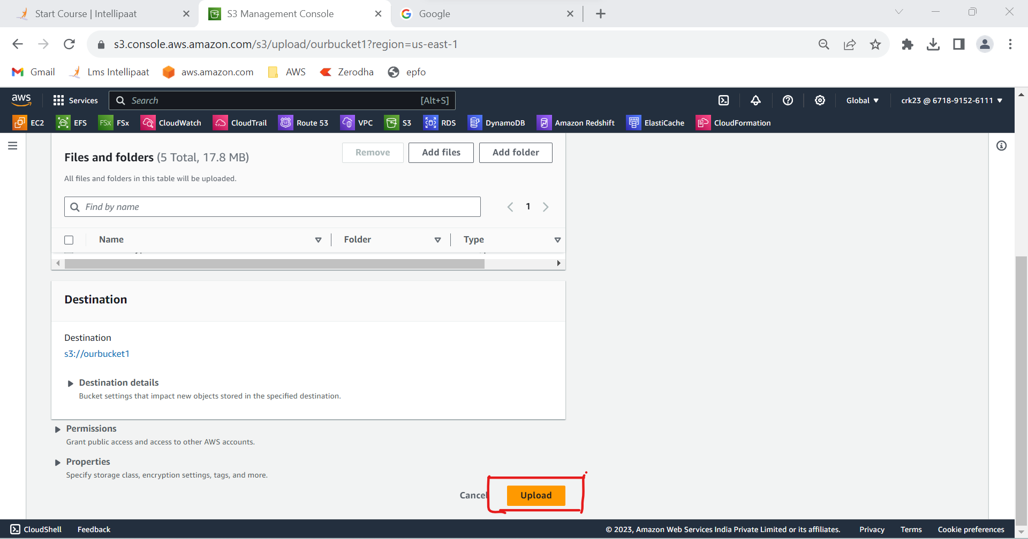

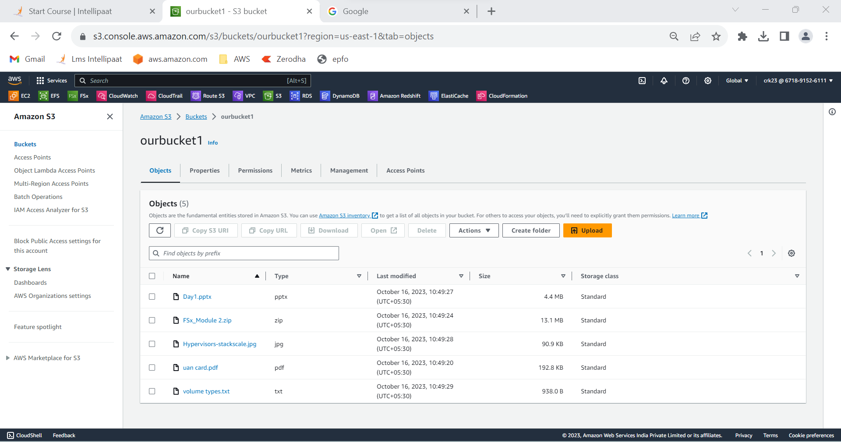

**OUTPUT :**

Created a bucket and uploaded five objects with different file extensions to the bucket.